**Hiring Criteria Worksheet**

# **Instructions**

1. Read through the hiring criteria and the details of what hiring managers are looking for versus what they negatively watch out for.
2. Complete the hiring criteria rubric grading your effectiveness with each criteria with an explanation of why you gave yourself that rating.
3. Complete a personal reflection listing your strengths and areas of growth for each hiring criteria.

# **Step One**

This table is for reference for Steps Two and Three. You do not need to fill out any sections in the below table. 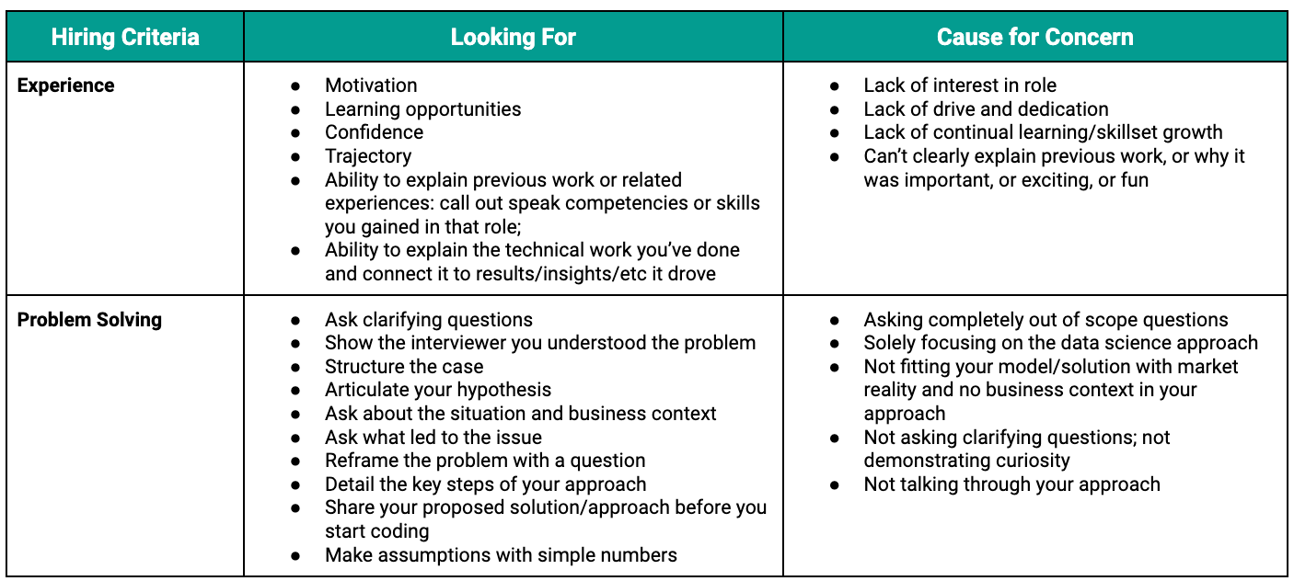

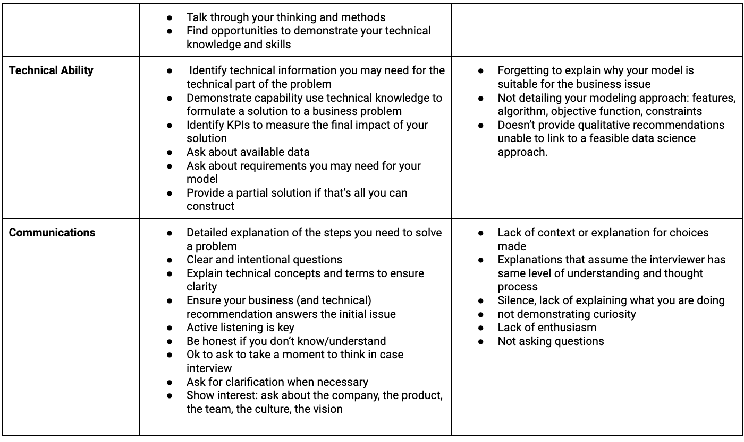

# **Step Two**

Think back over the work you’ve done for each of the technical interviews: the Whiteboarding Challenge, the Coding Test, and the Case Study. Referring to the table in Step One, think about how you either did not meet, met some, or met expectations based on the hiring criteria. Fill in this table with where you thought you met the expectations listed above.

| **Hiring Criteria** | **1**  *(Did Not Meet Any Expectations)* | **2**  *(Met Some Expectations)* | **3**  *(Meets Expectations)* |
| --- | --- | --- | --- |
| **Experience** |  |  |  |
|
|
|
| **Problem Solving** |  |  |  |
| **Technical Ability** |  |  |  |
| **Communication** |  |  |  |

# **Step Three**

Think back over the work you’ve done for each of the technical interviews: the Whiteboarding Challenge, the Coding Test, and the Case Study. Referring to the table in Step One, identify what you felt your strengths were and what are future opportunities for practice and growth when it came to your technical interviews.

| **Hiring Criteria** | **Strengths** | **Opportunities for Growth/Practice** |
| --- | --- | --- |
| **Experience** |  |  |
|
|
|
| **Problem Solving** |  |  |
|
|
|
| **Technical Ability** |  |  |
|
|
|
| **Communication** |  |  |
|
|
|